CF
Reasons for Australia’s Involvement in the Vietnam War
Study Unit: The Vietnam War

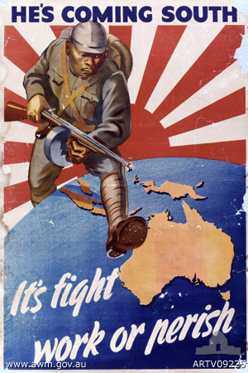
2012
By Daniel Dell’Armi
De La Salle College Revesby Heights
5/1/2012

Australia’s involvement in the Vietnam War was a direct link to its diplomatic relationship with the USA who adopted the political doctrine of capitalism, which opposed the Soviet Union ideology of communism, whereby ‘‘controlling wealth in the belief that the state should provide everyone with an equal share’’ (Anderson, 2005, pg.159), thus creating a political confrontation known as the Cold War (1949-1991). Australia’s strong diplomatic channels with the USA allowed it to become a major legal and political supporter of the leader of the Wester Bloc, especially when the hostilities of the Cold War era grew in intensity wherein the fear of the ‘red tide’ and its ‘iron curtain’, realisation of Australia’s defensive primitivism and the need for ‘‘great and powerful friends’’ (Martin, 16/4/2012) created social paranoia. The Liberal Government and its people reacted accordingly by supporting President Lyndon B. Johnson in the Vietnam War (1964-1975), which was colloquially known as Australia going ‘‘all the way with LBJ’’ (Australia and the Vietnam War: All the Way with LBJ, 2/4/2012).

The primary reason for Australia’s involvement in the Vietnam War was founded on the ‘fear of communism’. Australia had long suffered from a sense of uneasiness and fear regarding its position as the only western European settled country in Asia, hence employing a fear of the ‘red tide’ (communists) attempting to "descend upon Australia’’ (Why Australia entered the war, 3/4/2012). The communists were colloquially named the ‘reds’ due to the red communist flag which was the symbolic colour of revolution. Moreover, in1949, China, who had the largest population density, fell to the Soviet communists when Mao Zedong led the Chinese communist party to victory. The communisation by the ‘red tide’ began to increase in intensity as ‘‘in 1945, there was only one communist nation in the world; however at the end of 1949 there were eleven’’ (Mason, 2001, pg. 229). As a result, this fear resulted in national paranoia of ‘red china’ and subsequent communist expansion which was colloquially known as, ‘the fear of communism’ or ‘the fear of the red menace’. Winston Churchill consequently described the communist aggression on March 5, 1946 as an ‘‘iron curtain (which) has descended across the Continent...all these famous cities and the populations around them lie in what I must call the Soviet sphere’’ (Kreis, 22/4/2012). Thusly, the Australian Liberal Government under Robert Menzies (as of 10 December 1949) emphasised this fear through propaganda (refer to source 1, post bibliography). Henceforth, Australia subsequently began to experience social paranoia that was founded upon the ideology of the expanding ‘red tide’ which was a key element in the political and social tension that lead to Australia’s consequential involvement in the Vietnam War.
A pompous reason for Australia’s involvement in the Vietnam War was the coined fear of the ‘red tide’ or ‘yellow perils’ ascent from Vietnam. Ho Chi Minh’s North Vietminh, (Vietnamese Revolutionary Organisation, formulated in 1931), who believed in the liberation of Asian nations from western occupation. Consequently, surfaced fears of Asian communist aggression in the South Vietnamese border through vigilante guerrilla tactics conducted by the National Liberation Front (Vietcong) and thus leading to social paranoia based on the fears of a monolithic domino-like communist expansion of the ‘yellow perils’ (Palazzo, 2006, pg.12) throughout Asia and eventually to Australia (source 2 expresses communism as monolithic system). Henceforth, Australia was concerned that, should North Vietnam prevail and turn capitalist South Vietnam into a communist state, neighbouring countries such as Laos, Cambodia and Thailand would therefore profligate to become victim in what was called the ‘domino effect’, thus leading to the possible communisation of Australia (Why Australia entered the war, 3/4/2012). The bulletin, a common propaganda source in the post war period outlined the social policy against communist expansion, ‘‘since the loss of that country to the communists would inevitably be followed by the communisation of the rest of South-East Asia, Australia has no alternative but to contribute in some significant way to its defence’’ (Mason, 2001, pg.248). Thenceforth, Australia, with its interest in the South-East Asian region liberated of communism, became involved in the Vietnam War with the ideology of containing communist expansion, which was characterised by social paranoia founded upon the ‘fear of the communism.’

Australia’s involvement in the Vietnam War was linked to the fear of being isolated in the Pacific by communist forces, which was characterised by the paranoiac ‘fear of communism’ due to the communist aggression harboured by North Vietnam (yellow perils). According to secondary sources like visual maps, Vietnam is adjacent to Australia, therefore the Australian External Foreign Minister (Percy Spender) feared that ‘‘should the forces of communism prevail and Vietnam come under the heel of Communist China, Malaya is in danger of being outflanked and it, together with Thailand, Burma and Indonesia, will become the next direct object of further communist activities ...’’ (Mason, 2001, pg. 231), as metaphorically suggested by the ‘Domino Theory’ (as conveyed by source 3), leading to social paranoia of a physical Cold War confrontation. This fear of communist aggression was highlighted in Malaya (modern day Malaysia) when a communist movement had begun to operate in the Malay jungles from 1948. By 1950, ‘‘the situation had become known as the Malayan Emergency and an increased number of Australian troops were sent to oppose the communists’’ (Mason, 2001, pg. 234) as the intensity of guerrilla assaults heightened in 1955. The primary reason for Australia’s military commitment in Malaya was the social paranoia of being isolated in the Pacific by communist forces (Ross, 16/4/2012). Consequently, this same fear was thusly applied in the Vietnam controversy due to Australia’s fear of isolation engulfed by the ‘red tide’ and ‘yellow perils’. Thus, the political precedent that Australia had already committed itself to Malaya resulted in the national expectation that likewise Australia had the obligation to prevent communist aggression in Vietnam to thus prevent the isolation of Australia by communist forces, subsequently leading to Australia’s involvement in the Vietnam War.
The communist aggression in Asia and thus spreading to Australia was another integral reason for Australia’s involvement in the Vietnam War. The fear of communist aggression was highlighted by the capitalist Australian Liberal Party (ALP) who provoked fears of communist infiltration in Australia. Communism was becoming popular within the Australian boundaries, thus proliferating the ‘fear of communism’ and leading to the common colloquial phrase ‘‘red under the beds’’ (Weist, 2002, pg. 14). Robert Menzies publically announced that communism was ‘‘an act of criminal folly (and) to leave revolutionary Communists in key positions in those industries so that with all their smallness of numbers they may hope to achieve destructive results’’ (Warhaft, 2004, pg.253). Henceforth, the Menzies Government attempted to ban the Australian Communist Party. In April 1950, it introduced the Communist Party Dissolution Bill, which made the party illegal and allowed the Government to seize all its assets (property). However, the bill failed to become officially embedded in the Australian constitution due to the defected views of the High Court that declared the action unconstitutional. Despite this failure, the fear of the monolithic ‘red tide’ was effectively promoted, and reinforced when Vladimir Petrov ‘‘...handed over vital documents when he asked for political asylum... the documents seem likely to link espionage in Australia with the suspected overall spy system organised’’ (Anderson, 2005, pg. 164). Consequently, this ‘fear of communism’ manifested into social paranoia as it was believed that communism was ‘‘nearer, clearer and deadlier’’ (Anderson, 2005, pg. 161), as represented in source 4. Henceforth, this social paranoia contributed effectively to Australia’s involvement in the Vietnam War in an attempt to prevent communist aggression and its direct link to Australia.
Another ameliorative reason for Australia’s involvement in the Vietnam War was primed on the military doctrine of ‘forward defence,’ which was introduced on the basis of containing the social paranoia characterised by the communist aggression. In June 1950, war broke out in Korea when the communist army of North Korea invaded non-communist South Korea. President Truman of the United States interpreted the invasion as a clear example of communist aggression, and thus stated that he would provide freedom to any nation resisting communist control (Truman doctrines). The United Nations consequently sent an international force to support South Korea (Weist, 2002, pg.16); with the support of America, (a propaganda poster represents the US as a ‘backer’ in source 5). Hence, in accordance with the military policy ‘forward defence’, Australia was the first nation to support the United Nations and America by immediately ‘‘dispatching one aircraft carrier, two destroyers and a squadron of the RAAF’’ (Palazzo, 2006, pg.11) to thus prove its support as a loyal ally of the United States and to therefore strengthen the bonds between the two nations. Consequently, Australia entered the Vietnam War, in order to consequently obtain ‘‘great and powerful friends’’ (Martin, 16/4/2012) such as America to support them when in time of invasion, and thus creating an ‘insurance policy’ wherein improving Australia’s defensive integrity by taking conflict away from the Australian mainland (forward defence).
One of the potent reasons for Australia’s involvement in the Vietnam was to protect the defensive primitivism through the ANZUS and SEATO treaties. These treaties were introduced on the paramount ideology of gaining ‘‘great and powerful friends’’ (Martin, 16/4/2012) to thus improve the integrity of the diplomatic relationship between Australia and America. The SEATO treaty was ratified on 19 February 1955 at a meeting of treaty partners in Bangkok, Thailand (Pike, 18/4/2012). The treaty bound the signatories (the specific signatories are expressed in source 6) to recognise that an armed attack in the Pacific region on any of them would endanger the peace and safety of the others. The theme of the expansion of diplomatic channels with America presented in the SEATO treaty was reinforced by a supplementary ANZUS treaty wherein ‘‘the Parties will consult together whenever in the opinion of any of them the territorial integrity, political independence or security of any of the Parties is threatened in the Pacific’’ (Anzus, 20/4/2012). Hence, these treaties essentially bonded America to assist Australia in the event of an invasion on home soil due to the defensive primitivism of Australia. Thus, highlighting the need to thus gain ‘‘great and powerful friends’’ (Martin, 16/4/2012) and henceforth acquire ‘‘a mutual friendship’’ (Ross, 1995) with America, as a result, Australia entered the Vietnam War to improve its diplomatic relationship with America in order to secure Australia’s defence by increasing the number of allies, America, to defend Australia in the event of military invasion.
The essential reason for Australia’s involvement in the Vietnam War was founded on the diplomatic principle of acquiring a ‘‘mutual friendship’’ (Weist, 2002, pg. 15) with America. This principle became the basis for the Australian Liberal Government to improve the diplomatic integrity between the U.S and Australian states. In January 1966, Robert Menzies retired and Harold Holt became the new Prime Minister of Australia. Holt’s foreign ideology was that Australia had a responsibility to support the United States, and thus his campaign became colloquially known as ‘‘all the way with LBJ’’ (Australia and the Vietnam War: All the Way with LBJ, 3/4/2012). This movement was supported when Holt visited Washington D.C in January 1966 and pledged allegiance to President Lyndon B. Johnson and quoted him as ‘‘an understanding friend but one staunch in the belief of the need for our presence with you in Vietnam...all the way with LBJ’’ (Mason, 2001, pg. 248). Moreover, LBJ visited Australia in 1966 and was greeted warmly by approximately 10,000 people (conveyed in the visual photograph in source 7), which furthermore depicted America’s alliance with Australia, hence, Australia’s commitment to the USA. On the spur of this foreign commitment, in March 1966, following a direct request from the United States, Australia decided ‘‘to send to Vietnam an infantry battalion of 800 men, with some 100 personnel in logistical support, to serve with the United States forces in assisting in the defence of the Republic of Vietnam’’ (Mason, 2001, pg. 244). Henceforth, the foreign diplomatic commitment to the ‘‘mutual ‘friendship’’ (Weist, 2002, pg. 15) with the United States, and the ideology to prove to America that they were more than ‘‘paper allies’’ (Doyle, 2002, pg. 7) consequently lead to Australia’s support of America in the Vietnam War.

In summary, Australia’s involvement in the Vietnam War was the foundation of social paranoia promoted by the fear of the ‘red tide’ and its ‘iron curtain’, realisation of Australia’s defensive primitivism and the need for ‘‘great and powerful friends’’ (Martin, 16/4/2012) Thus, these factors created a high sense of political tension among the Government and its people, thusly resulting in Australia’s support of USA and involvement in the Vietnam War through the political movement known as ‘‘going all the way with LBJ’’ (Australia and the Vietnam War: All the Way with LBJ, 2012).

Note: The extra ¼ of a page has been the result of the effects of the quotations, references, and footnotes, which are not included in the word count.

(Harvard/ Author-Date System):

Books
- Wiest, A; Cullen & R, Worthington, A. (2002). Essential Histories: The Vietnam War (1956-1975).1st edition. Osprey Publishing. Great Britain. Pp.14-16.
- Doyle, J; Grey, J & Pierce, P. (2002). Australia’s Vietnam War. 1st Edition. Undisclosed. United Sates of America. Pp. 6-7.
- Palazzo, A. (2006). Australian Military Operations in Vietnam. Australian army campaigns; 3. 2nd Edition. Trojan Press pty ltd. Thomastown Victoria, Australia. Pp.11-12.
- Anderson, M; Low, A. Conroy J & Keese I. (2005). Retro Active 2. 2nd edition. John Wiley & Sons Australia, Ltd. 33 Park Road, Milton, QLD 4064 Australia. Ch. 6 (Politics, Power and Protest in the Vietnam War era).
- Mason, J. (2001). Experience of Nationhood: Australia in the Vietnam Era. 5th Edition. McGraw-Hill Australia. Australia. Ch. 5, pp. 224-250.
- Warhaft, S; Deverall, T. (2004). Well may we say it: The speeches that made Australia. 1st edition. Black inc. Melbourne Victoria 3000 Australia. Pg. 253.

Websites
- Australia and the Vietnam War: All the way with LBJ. (2012). 1st edition. (Internet). Department of Veterans’ Affairs: Board of Studies. 2/4/2012. URL: http://vietnam-war.commemoration.gov.au/all-the-way-with-lbj/index.php
- Ross, B. (1995). Australia's Involvement in the Vietnam War: The Political Dimension Part 1. 1st Edition. (Internet). 16/4/2012 Undisclosed publisher. URL: http://www.vvaa.org.au/bross-2.pdf
- Why Australia entered the war. (2012). 1st Edition. (Internet). 3/4/2012. Skwirk. URL: http://www.skwirk.com.au/p-c_s-14_u-116_t-314_c-1060/why-australia-entered-the-war/nsw/history/australia-in-the-vietnam-war-era/why-did-australia-become-involved-in-the-vietnam-war-
- Kreis, S. (2000). Winston Churchill's Iron Curtain Speech. 1st edition. (Internet). 22/4/2012. The History Guide: Lectures on Twentieth Century Europe. URL: http://www.historyguide.org/europe/churchill.html
- ANZUS. (2012). 1st edition. (Internet). 20/4/2012. Wikipedia. URL: http://en.wikipedia.org/wiki/ANZUS
- Pike, J. (2000-2012). Southeast Asia Treaty Organization (SEATO), 1954. 1st edition. (Internet). 18/4/2012 Global Security.org. URL: http://www.globalsecurity.org/military/world/int/seato.htm
- Martin, A. (2000). Menzies, Sir Robert Gordon (Bob) (1894–1978). 1st edition. (Internet). 16/4/2012. Australian Dictionary of Biography, National Centre of Biography, Australian National University. URL: http://adb.anu.edu.au/biography/menzies-sir-robert-gordon-bob-11111

Appendix

Source 1 (Experience of Nationhood) Source 3(Essential Histories)
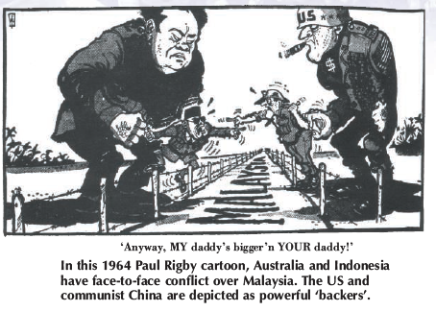
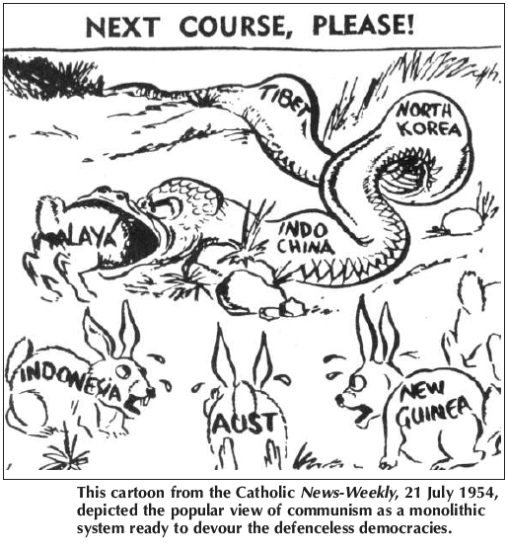

Source 4 (Retro Active 2)
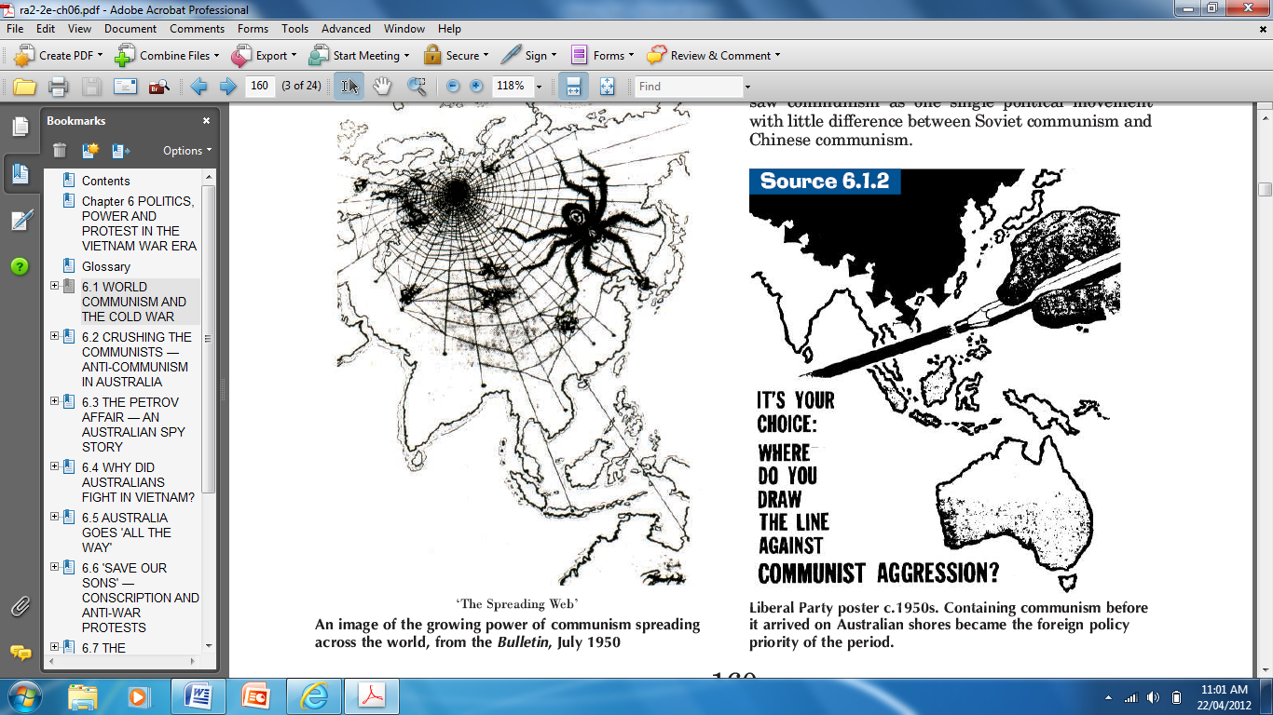
Source 2 (Essential Histories)
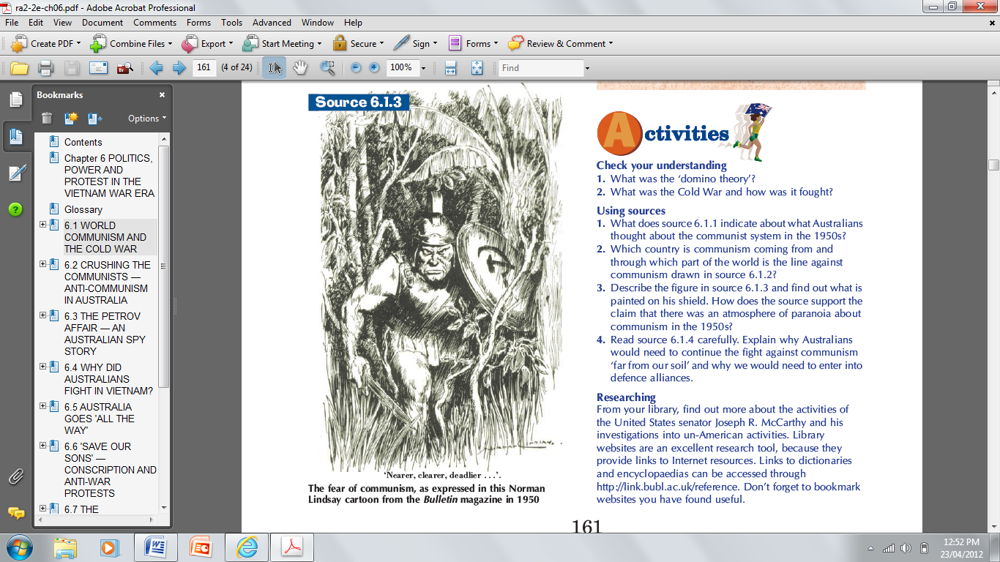

Source 5 (Retro Active 2) Source 7 (Experience of Nationhood)
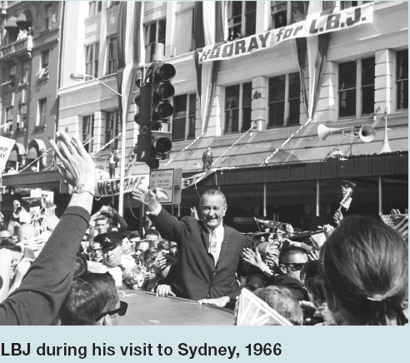

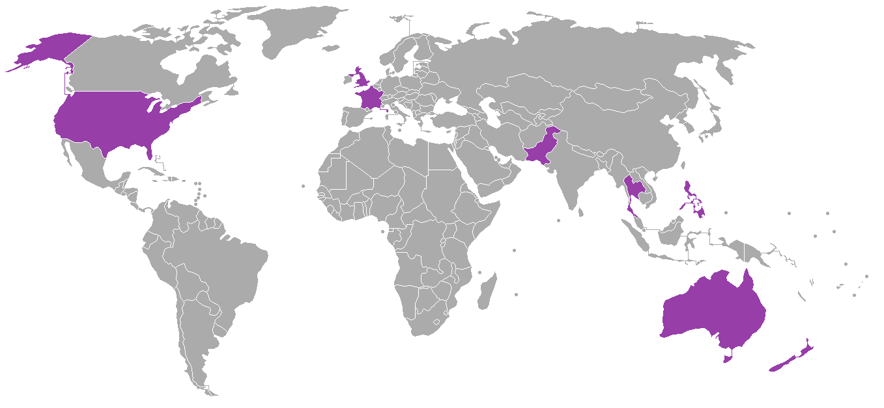
Source 6 (http://www.google.com.au/imgres?q=SEATO+treaty+nations&hl=en&biw=1619&bih=783&gbv=2&tbm=isch&tbnid=Z03CIVcsj)

